Covid-19 Data Analysis – Final SQL Report
This report presents a complete analysis of the Global COVID Dataset using SQL server.it
Includes data cleaning, exploration, descriptive statistics, central tendency, dispersion,
Percentiles, top records , correlation analysis, ranking and regression modelling.
1.Data Import & Cleaning
• The data global_covid_data.xlsx was imported into SQL server as Covid Data.
•Columns included province, country, Latitude, Longitude, Date, Confirmed, Deaths,
Recovered, Active, incidence Rate, and case Fatality Ratio.
• All rows were checked for null values. Missing values appeared mainly in numeric fields
Like recovered, active, and incidence rate.
•Null in numeric fields were replaced with 0 to avoid calculation errors in statistical analysis
• This ensured a clean dataset ready for analysis.
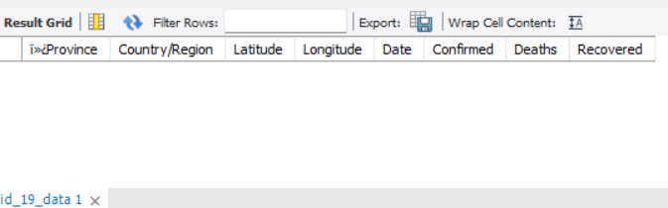
2. Basic Data Exploration
• The first 10 rows confirmed correct import and consistent column formatting.
•Dates were converted using STR_TO_DATE () for proper time_series analysis.
•Distinct month per year were extracted to analysis seasonal patterns.
•The earliest date and latest date in the dataset were identified, defining the analysis
Timeframe.
•Year_month row counts revealed periods of high and low reporting activity.
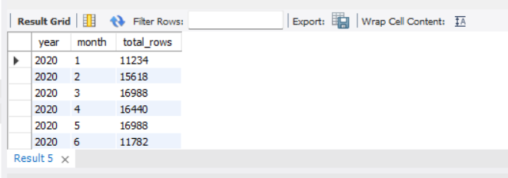

3.Descriptive Statistics (Monthly Trends)
• Monthly MIN, MAX, and TOTAL values were calculated for confirmed, deaths, and recovered.
• This highlighted the peak outbreak months where maximum case changed over time.
•Death and recovered totals helped compare disease severity against recovery rates.
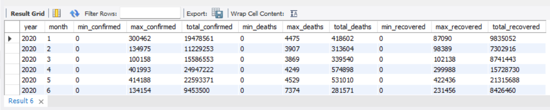
4. Central Tendency Analysis
•Averages (mean) showed typical case counts for each month.
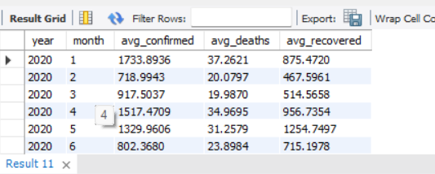
•Median were computed using window function, giving a more stable center point.
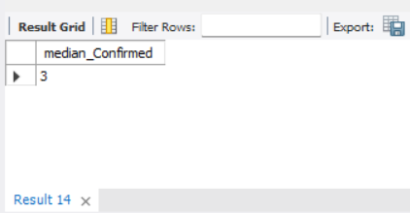

•Mode values revealed the most frequently occurring case number per month.
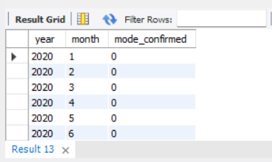
•Together, these measures indicated whether tha data was skewed.
5.Dispersion (spread of Data)
•Variance and standard deviation were computed for confirmed, deaths, and recovered.
•A high in confirmed cases showed large fluctuation during outbreak peaks.
•Death and recovery values had lower but noticeable spread.
•These metrics showed how unpredictable daily case counts were.
6.Percentile Distribution
•The 50th (median), 60th, 90th, and 95th percentiles were computed.
•Higher percentile (90th, 95th) indicated extreme case spikes.
•Percentiles helped understand how severe the upper-tail case distribution was.
7.Top Record (Critical Observation)
•Top 10 record with highest confirmed, deaths, and recovered were extracted.
•These records indicated the worst-hit dates or region.
•The highest confirmed cases aligned with major global outbreak waves.
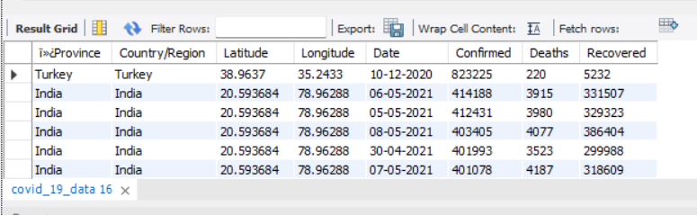

8.correlation analysis
•Confirmed vs deaths showed a strong positive correlation- higher cases typically led to more deaths.
•Confirmed vs recovered also showed a positive correlation- increasing cases eventually
To more recoveries.
•Deaths vs recovered correlation was weaker, suggesting recovery depended more on confirmed cases than death counts.
•This correlation validated expected epidemiological relationship.
9.Ranking
•ROW_NUMBER () was used to rank records by highest confirmed cases.
•Ranking allowed identification of top outbreak dates or region quickly.
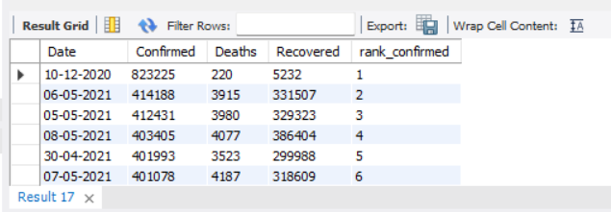
10.Regression Model (Predicting Deaths from Confirmed Cases)
•A simple linear regression was computed using SQL.
•Slope (m) measured how many deaths increase for every 1 confirmed case.
•Intercept (b) estimated baseline deaths when zero cases are recorded.
•Final regression equation:
Deaths = m Confirmed + b
•This model showed a strong relationship and could forecast deaths based on case counts.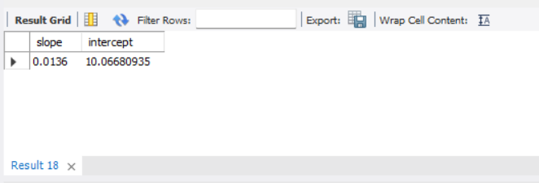
11.Final Insights & Conclusion
•Confirmed cases showed clear spikes corresponding to known global covid waves.
•Deaths lagged behind confirmed cases but followed a similar pattern.
•Recovery rates increased strongly after each wave, indicating improved medical response.
•Strong positive correlation confirmed cases drove deaths and recoveries.
•percentiles revealed right-tail distribution – a few days had extreme high case counts.
•Overall, the dataset demonstrated real pandemic behaviour with strong statistical consistency.

